Review Problems Sections 5.4-5.6

Review all HOMEWORK and NOTES from the three sections in addition to doing the following problems.

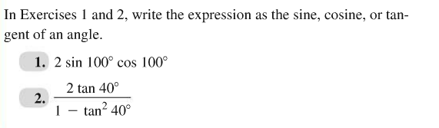

Find the exact values of $sin2u, cos2u,$ and $tan2u$ using the double-angle formulas.





Find the exact solutions of the equation in the interval [0, 2 $π$).

